**CCSU Actions to improve the assessment of General Education**

In 2013, the New England Association of Schools and Colleges (NEASC) asked CCSU to focus on the assessment of General Education. The specific request was to give emphasis to the institution’s success in implementing a new general education curriculum (not implemented, see [Minutes, Faculty Senate Feb. 11, 2015](http://web.ccsu.edu/facultysenate/minutes1415feb11.asp)) and to include an approach to the assessment of student learning outcomes in the general education core. NEASC further advised CCSU to give emphasis to Standards 4.15 (formerly 4.19) and 4.16 within Standard Four: *The Academic Program*:

*4.15 Graduates successfully completing an undergraduate program demonstrate competence in written and oral communication in English; the ability for scientific and quantitative reasoning, for critical analysis and logical thinking; and the capability for continuing learning, including the skills of information literacy.  They also demonstrate knowledge and understanding of scientific, historical, and social phenomena, and a knowledge and appreciation of the aesthetic and ethical dimensions of humankind.*

*4.16 The general education requirement is coherent and substantive.  It embodies the institution’s definition of an educated person and prepares students for the world in which they will live.  The requirement informs the design of all general education courses, and provides criteria for its evaluation, including the assessment of what students learn.*

This report attempts to document CCSU’s progress on assessing General Education learning outcomes.

[CCSU’s General Education program](http://ccsu.smartcatalogiq.com/en/current/Undergraduate-Graduate-Catalog/Undergraduate-General-Education-Program) provides students with an educational foundation on which to build their intellectual, personal, civic, social, and cultural lives during their undergraduate years and beyond. The university’s General Education Learning Outcomes (Objectives) articulate broad competencies of what students should know and be able to do upon graduation. To attain these competencies, students forge their educational path through a series of discipline-based courses in designated Study and Skill Areas. Importantly, GenEd competencies are not unique to schools, disciplines, or individual departments. Indeed, such competencies even transcend specifically designated GenEd courses.

**General Education Assessment at the Department Level**

In the Spring of 2008, CCSU Faculty Senate passed a [resolution](http://web.ccsu.edu/facultysenate/minutes0708apr14.asp) to engage in a [peer-reviewed process for the assessment of student learning](http://www.ccsu.edu/oira/assessment/AAP.html), both in the discipline and in general education, thus giving faculty the responsibility for assessing student learning. At that same time, the [Academic Assessment Committee (AAC)](http://web.ccsu.edu/facultysenate/files/Supporting_Documents_2007-08/Assessment%20Cmte%20By-laws.pdf) was established and, with support from the [Office of Institutional Research and Assessment (OIRA)](http://www.ccsu.edu/oira) continues to be responsible for providing feedback to departments about their academic program assessment as well as coordinating the general education assessment initiatives. Departments offering general education courses are required by the [Policy on Academic Assessment](http://www.ccsu.edu/oira/assessment/AAC/policy.html) to include the findings from their evaluation of General Education outcomes. The department-centered assessment process is still occurring and the effectiveness of these locally devised general education assessments are being monitored and evaluated by the AAC. This is, in effect, an integral part of the degree program assessment review. For example, the Departments of English and Geological Sciences have identified GenEd learning outcomes which are clearly linked with their course content and established well thought-out assessments to evaluate students’ competencies in these respective areas.

However, for many departments, this continues to be challenging. Departments struggle to independently develop and implement reliable General Education assessments. This is due, in part because (1) there is no common rubric for departments to measure any given learning objective; (2) there are no common expectations for student performance from one department to the other, and (3) there are no resulting discussions where departments communicate the outcomes of the students’ learning between themselves. Department-administered assessments vary, resulting in a lack of continuity and/or means by which data can be generalized across the institution. In effect, departments are independently assessing student performance in the course rather than the learning outcomes themselves.

**Partnering with the Multi-State Collaborative (MSC) for General Education Assessment**

In Spring 2014, the opportunity to participate in the [Multi-State Collaborative (MSC)](http://www.sheeo.org/projects/msc-multi-state-collaborative-advance-learning-outcomes-assessment) emerged. As part of this nine-, now thirteen-state assessment initiative, coordinated and developed by the State Higher Education Executive Officers ([SHEEO](http://www.sheeo.org/about)) and the American Association for College & Universities ([AAC&U](https://www.aacu.org/about)), CCSU began a new assessment chapter on campus. Since then, our philosophy about General Education assessment has matured across campus as we considered how our GenEd Learning Outcomes might best be assessed across disciplines in a valid and reliable manner. In June 2013, four CCSU faculty and the OIRA Director attended the [AAC&U General Education Institute in Vermont](https://www.aacu.org/press/press-releases/122-campuses-selected-attend-aacu-summer-institutes-general-education-and). Then, in June 2014, five CCSU representatives attended the New England Educational Assessment Network ([NEEAN](http://neean.org/about-us)) General Education Assessment Summer Institute. These professional development institutes, as well as other assessment conferences, gave CCSU teams opportunities to learn from other institutions and develop new GenEd assessment strategies.

There were two particularly attractive guiding principles for the MSC initiative: (1) to work with faculty-designed, course-embedded assignments and (2) to use assignments that were important to the student (i.e., graded). Additionally, it became apparent that AAC&U’s [VALUE rubrics](https://www.aacu.org/value-rubrics) were similarly linked to CCSU’s GenEd Outcomes and that a move toward this more proficiency-based assessment model was fitting. First, the rubrics articulate fundamental criteria/dimensions for measuring Learning Outcomes, thus providing CCSU with performance descriptors to effectively measure our students’ level of attainment of key learning criteria/dimensions. Second, the rubrics are nationally-tested, thus allowing us to gauge our data against national scoring norms while meeting the validity and reliability standards that we expect. Third, VALUE rubrics provide us with a means for assessing competencies delivered in our GenEd courses, regardless of course discipline. A key feature of the VALUE rubrics is that they are not discipline specific and therefore can be effectively used to measure a learning outcome regardless of subject. Fourth, the MSC offered us a fiscally-attainable and sustainable assessment model. The advantage of the VALUE rubrics to best position our General Education undergraduate learning became clearly evident and has, since 2014, allowed CCSU to nationally place our students’ learning within a basic framework of expectations and to share results with the CCSU community using a common dialog and understanding of student success.

Between 2015 and 2017, to further prepare for leadership in CCSU’s MSC participation, five CCSU Faculty from Anthropology, Art, Economics, Political Science, and Psychological Science have participated in AAC&U’s national MSC project scorer training meetings to assess common VALUE rubrics in the areas of [Quantitative Literacy/Reasoning (QR](https://www.aacu.org/value/rubrics/quantitative-literacy)), [Written Communication (WC)](https://www.aacu.org/value/rubrics/written-communication), [Critical Thinking (CT)](https://www.aacu.org/value/rubrics/critical-thinking) and [Civic Engagement (CE)](https://www.aacu.org/civic-engagement-value-rubric). The training focused on (a) building state and institutional capacity among faculty participants who would subsequently serve as campus trainers, leading their faculty colleagues in scoring calibration sessions; (b) developing a shared understanding of how to align VALUE rubric criteria with features found in authentic student work; and (c) learning how faculty can use results at the institution level in order to engage in collaborative, evidence-based discussions on how to advance student learning. After training, CCSU faculty scored up to 100 national student work samples/artifacts. As nationally-trained project scorers, these five faculty have provided invaluable leadership to CCSU as we began to develop and implement the VALUE rubric model at the institution level for GenEd assessment.

**CCSU’s Pilot Year in MSC: 2014-15**

To prepare for our pilot year participation in the MSC, a call went out in fall 2014 for faculty whose voluntary participation would ultimately set the foundation for the assessment of our General Education Learning Outcomes assessment. OIRA hosted assignment alignment workshops where interested faculty could review Critical Thinking, Quantitative Reasoning, and Written Communication VALUE rubrics, and widen their understanding of how their course-embedded assignments might be linked with specific CCSU Learning Outcomes and VALUE rubric criteria/dimensions. Throughout the 2014-15 academic year, participating faculty voluntarily collected, prior to grading, assignments (artifacts) from undergraduate students in their courses. Then, faculty submitted these student artifacts to OIRA where they were de-identified (viz., removal of all student and faculty names and identifiers, references to courses, CCSU, or Connecticut) and recoded. Artifacts from students who had completed 90+ credits were not only uploaded into the national MSC database where artifacts were scored by MSC faculty from other states, but artifacts were also kept for scoring by CCSU trained faculty during the first-ever two-day assessment retreat in June 2015. The remaining artifacts were scored at a later retreat.

To ensure transparency in this initiative, debriefing or update sessions were and continue to be offered at each milestone, essentially providing status updates to interested faculty regarding what has been completed to date, requesting feedback on what is or is not working well, and the most recent results, both institution-wide and nationally. Attending to OIRA’s confidentiality commitment, participating faculty receive reports on how students in their course(s) scored; these data are not made available to other faculty.

In the 2014-15 pilot year, 27 CCSU faculty representing 46% (n=18) of our academic departments across schools voluntarily participated in collecting 533 student artifacts of which 283 were submitted to the MSC (Tables 1 and 2). This response yielded the 6th highest submission of all 60 institutions participating in the MSC initiative nation-wide (Table 3).

Table 1. CCSU Pilot Year (Year 1, 2014-15) Participation Rate by Student Level – Number of Artifacts Collected for each Learning Outcome by Student Level

|  |  |  |  |  |  |  |
| --- | --- | --- | --- | --- | --- | --- |
| **Learning Outcome** | **Fresh** | **Soph** | **Jr** | **Sr** | **Total** |  |
| **Critical Thinking (33 Majors)** | 16 | 21 | 58 | 130 | 225 |
| **Quantitative Reasoning (19 majors)** |  | 6 | 29 | 82 | 117 |
| **Written Communication (28 Majors)** | 13 | 19 | 62 | 97 | 191 |
| **Grand Total (45 undergraduate majors represented)** | 29 | 46 | 149 | 309 | 533 |

Enthusiasm for the MSC project, however, was also met with other CCSU faculty who expressed concerns about perceived increase in work load, conceptual concerns, and financial hardships that the MSC assessment model may pose to departments. Nonetheless, an [Academic Assessment Committee Resolution](http://web.ccsu.edu/facultysenate/files/Supporting_Documents_2014-15/Resolution%20Academic%20Assessment%20Committee.pdf) to the CCSU Faculty Senate in April 2015 was [passed](http://web.ccsu.edu/facultySenate/minutes1415apr27.asp), endorsing the AAC to pilot an in-house MSC model to assess CCSU’s GenEd Learning Outcomes.

CCSU’s participation in the MSC and receipt of benchmark results (Table 4) from other 4-year institutions was critical in that it helped to set our senior students’ scores into a national context. Nationally, the average score for seniors across all competencies ranged from 2 to 2.5 depending on the rubric. This was surprising in that we anticipated senior level work to score between 3 and 4 on each rubric. MSC 2014-15 pilot year data showed CCSU results to be slightly higher than the national 4-year average for Critical Thinking and Quantitative Reasoning while slightly lower for Written Communication. All calculations for this comparison included values of zero[1].

Table 2. CCSU Pilot Year 2014-15 Participation by Faculty and Student Level

|  |  |  |  |  |  |  |
| --- | --- | --- | --- | --- | --- | --- |
| **Participation: 27 Faculty in 29 Courses** | | | | | | |
| **Learning Outcome & Faculty** | **First Year** | **Sophomore** | **Junior** | **Senior** | **Total for CCSU**  **Gen Ed** | **Total for MSC** |
| **Critical Thinking (33 Majors)** | **16** | **21** | **58** | **130** | **225** | **119** |
| Adams |  |  |  | 10 | 10 | 10 |
| Broadus-Garcia |  |  |  | 4 | 4 | 4 |
| DiPlacido | 1 | 6 | 15 | 30 | 52 | 29 |
| Durant |  |  |  | 16 | 16 | 14 |
| Koski |  |  | 5 | 15 | 20 | 13 |
| Moriarty | 1 | 1 | 7 | 10 | 19 | 10 |
| Mulrooney |  |  | 3 | 4 | 7 | 3 |
| O'Connor |  |  | 4 | 1 | 5 | 1 |
| Petterson |  |  | 1 | 14 | 15 | 13 |
| Pozorski |  | 1 | 8 | 10 | 19 | 8 |
| Smith | 1 | 5 | 6 | 10 | 22 | 9 |
| Specter - Hist 344 |  | 3 | 7 | 5 | 15 | 5 |
| Specter - Hist 122 | 13 | 5 | 2 | 1 | 21 | N/A |
| **Quantitative Reasoning (19 majors)** | **0** | **6** | **29** | **82** | **117** | **78** |
| Kostelis |  |  | 7 | 10 | 17 | 9 |
| Larsen |  | 1 | 4 | 2 | 7 | 2 |
| Liard-Muriente |  | 5 | 13 | 17 | 35 | 16 |
| Robinson |  |  | 3 | 17 | 20 | 16 |
| Vasko |  |  | 2 | 36 | 38 | 35 |
| **Written Communication (28 Majors)** | **13** | **19** | **62** | **97** | **191** | **87** |
| Baratta |  | 6 | 8 | 1 | 15 | 1 |
| Cohen |  |  |  | 9 | 9 | 9 |
| Crespi |  |  | 3 | 12 | 15 | 11 |
| Dharavath |  |  |  |  | 0 | 0 |
| Durant |  |  |  | 16 | 16 | 14 |
| Gigliotti |  |  | 5 | 7 | 12 | 7 |
| Larsen |  | 2 | 6 | 2 | 10 | 2 |
| Mijid |  |  | 5 | 4 | 9 | 4 |
| Mulcahy |  |  |  | 16 | 16 | 16 |
| Pozorski |  | 1 | 8 | 10 | 19 | 8 |
| Sideriadis |  | 2 | 17 | 3 | 22 | 2 |
| Specter - Hist 122 | 13 | 5 | 2 | 1 | 21 | N/A |
| Specter - Hist 344 |  | 3 | 7 | 5 | 15 | 5 |
| Tracey |  |  | 1 | 5 | 6 | 4 |
| Zanella |  |  |  | 6 | 6 | 4 |
| **Grand Total (45 majors)** | **29** | **46** | **140** | **318** | **533** | **284** |

Table 3. MSC 2014-15 – Pilot Year (Year 1) Participation across the Nine States

|  |  |  |  |  |  |  |  |  |  |
| --- | --- | --- | --- | --- | --- | --- | --- | --- | --- |
| State | Institution | Critical Thinking | | Quantitative | | Written | | Total Faculty  (duplicated) | Total Artifacts |
| Faculty  Count | Artifact  Count | Faculty  Count | Artifact  Count | Faculty  Count | Artifact  Count |
| MO | Truman State University | 1 | 95 | 9 | 178 | 1 | 94 | 11 | 367 |
| MN | Inver Hills Community College | 10 | 87 | 17 | 125 | 16 | 112 | 43 | 324 |
| UT | Salt Lake Community College | 9 | 84 | 8 | 109 | 8 | 108 | 25 | 301 |
| MA | Framingham State University | 16 | 101 | 12 | 100 | 17 | 99 | 45 | 300 |
| MN | St Olaf College | 10 | 89 | 11 | 98 | 12 | 104 | 33 | 291 |
| CT | Central Connecticut State University | 12 | 119 | 5 | 78 | 13 | 86 | 30 | 283 |
| MN | Hamline University | 15 | 93 | 7 | 82 | 17 | 98 | 39 | 273 |
| MN | Minneapolis Community and Technical Colleg | 9 | 90 | 8 | 76 | 9 | 95 | 26 | 261 |
| MO | Central Methodist University | 10 | 105 | 7 | 67 | 10 | 89 | 27 | 261 |
| MO | Southeast Missouri State University | 5 | 64 | 6 | 93 | 9 | 98 | 20 | 255 |
| IN | Vincennes University | 26 | 99 | 16 | 75 | 18 | 76 | 60 | 250 |
| KY | University of Kentucky |  |  | 9 | 181 | 7 | 54 | 16 | 235 |
| MN | Gustavus Adolphus College | 9 | 79 | 7 | 63 | 8 | 78 | 24 | 220 |
| OR | Chemeketa Community College |  |  | 3 | 135 | 5 | 78 | 8 | 213 |
| RI | Community College of Rhode Island |  |  | 16 | 122 | 23 | 86 | 39 | 208 |
| MN | Saint Cloud State University | 11 | 74 | 9 | 49 | 12 | 73 | 32 | 196 |
| MN | The College of Saint Scholastica | 11 | 61 | 8 | 60 | 11 | 70 | 30 | 191 |
| OR | Oregon Institute of Technology | 3 | 23 | 9 | 79 | 9 | 85 | 21 | 187 |
| CT | Southern Connecticut State University | 4 | 35 | 6 | 69 | 10 | 76 | 20 | 180 |
| CT | Three Rivers Community College |  |  | 15 | 90 | 13 | 86 | 28 | 176 |
| UT | Snow College |  |  | 16 | 91 | 25 | 81 | 41 | 172 |
| MA | University of Massachusetts Lowell | 6 | 53 | 5 | 40 | 8 | 78 | 19 | 171 |
| UT | Utah State University |  |  | 8 | 78 | 11 | 78 | 19 | 156 |
| MA | Northern Essex Community College | 18 | 55 | 8 | 27 | 17 | 71 | 43 | 153 |
| MN | North Hennepin Community College | 34 | 64 | 28 | 61 | 12 | 22 | 74 | 147 |
| OR | Portland Community College | 6 | 40 | 2 | 17 | 18 | 75 | 26 | 132 |
| IN | Purdue University Calumet | 15 | 47 | 12 | 25 | 26 | 58 | 53 | 130 |
| UT | University of Utah |  |  | 7 | 74 | 7 | 52 | 14 | 126 |
| MA | Worcester State University | 9 | 50 | 3 | 20 | 8 | 45 | 20 | 115 |
| CT | Manchester Community College |  |  | 3 | 25 | 12 | 88 | 15 | 113 |
| CT | Naugatuck Valley Community College |  |  | 9 | 59 | 9 | 52 | 18 | 111 |
| MA | Middlesex Community College | 6 | 38 | 5 | 33 | 5 | 40 | 16 | 111 |
| MN | Southwest Minnesota State University | 4 | 31 | 5 | 27 | 8 | 52 | 17 | 110 |
| MA | Bristol Community College | 14 | 49 | 8 | 27 | 9 | 33 | 31 | 109 |
| IN | Indiana University Bloomington | 1 | 10 | 4 | 18 | 12 | 78 | 17 | 106 |
| MN | Augsburg College |  |  |  |  | 14 | 101 | 14 | 101 |
| MA | North Shore Community College | 7 | 39 | 3 | 26 | 6 | 35 | 16 | 100 |
| MA | Fitchburg State University | 2 | 43 | 1 | 9 | 2 | 47 | 5 | 99 |
| MN | University of Minnesota-Morris |  |  |  |  | 6 | 97 | 6 | 97 |
| MN | Minnesota West Community and Technical College | |  | 22 | 51 | 26 | 45 | 48 | 96 |
| KY | Bluegrass Community and Technical College |  |  | 5 | 58 | 6 | 35 | 11 | 93 |
| CT | Western Connecticut State University |  |  | 3 | 35 | 5 | 53 | 8 | 88 |
| MO | Ozarks Technical Community College | 2 | 28 | 1 | 45 | 1 | 14 | 4 | 87 |
| MN | Minnesota State Community and Technical C | 1 | 34 |  |  | 3 | 49 | 4 | 83 |
| MA | Cape Cod Community College | 17 | 27 | 14 | 32 | 11 | 24 | 42 | 83 |
| CT | Eastern Connecticut State University | 3 | 30 | 1 | 5 | 5 | 47 | 9 | 82 |
| MO | University of Central Missouri | 1 | 19 | 1 | 19 | 3 | 42 | 5 | 80 |
| MN | Itasca Community College | 8 | 41 |  |  | 8 | 39 | 16 | 80 |
| MA | Berkshire Community College | 6 | 25 | 2 | 9 | 9 | 46 | 17 | 80 |
| MN | Century College |  |  | 7 | 43 | 7 | 34 | 14 | 77 |
| MA | Mount Wachusett Community College | 2 | 12 | 4 | 25 | 4 | 31 | 10 | 68 |
| MA | Holyoke Community College | 8 | 21 | 4 | 22 | 8 | 25 | 20 | 68 |
| MA | Massasoit Community College | 4 | 16 | 2 | 9 | 5 | 36 | 11 | 61 |
| IN | Ivy Tech Community College of Indiana | 1 | 10 |  |  | 6 | 37 | 7 | 47 |
| MN | Hibbing Community College | 7 | 28 |  |  | 3 | 13 | 10 | 41 |
| MN | Vermilion Community College | 3 | 16 |  |  | 4 | 14 | 7 | 30 |
| KY | Hazard Community and Technical College | 1 | 6 |  |  | 6 | 22 | 7 | 28 |
| OR | Oregon State University |  |  |  |  | 3 | 24 | 3 | 24 |
| OR | Southwestern Oregon Community College |  |  |  |  | 12 | 23 | 12 | 23 |
| IN | Purdue University North Central | 1 | 9 |  |  |  |  | 1 | 9 |

Table 4. National MSC Scores Compared to CCSU's Artifacts Scored by MSC Faculty (zeros included)

|  |  |  |
| --- | --- | --- |
| Learning Outcome | National MSC Average Score (4-year institutions, N=31) | CCSU's MSC  Faculty Score |
| Critical Thinking | 1.99 | 2.04 |
| Quantitative Reasoning | 2.12 | 2.38 |
| Written Communication | 2.53 | 2.58 |

By setting the scores in a national context, we are able to gauge where our seniors are in comparison to other 4-year institutions and see the scores in a somewhat more palatable light. These data clearly indicate areas of strength and weakness. In [Quantitative Reasoning](https://www.aacu.org/value/rubrics/quantitative-literacy), student performance in *Calculation* and *Representation* ranked highest among the criteria/dimensions with students’ ability to *Apply/Analyze* data and make and evaluate *Assumptions* scoring lowest. In [Critical Thinking](https://www.aacu.org/value/rubrics/critical-thinking), students’ performance in *Explanation of Issues* and *Conclusions* ranked highest, but their ability to present a specific *Position* or effectively address *Context* and assumptions was weaker. In [Written Communication](https://www.aacu.org/sites/default/files/files/VALUE/WrittenCommunication.pdf), students scored highest in their ability to convey meaning through *Control of Syntax and Mechanics* and address *Context of and Purpose for Writing,* but scored lowest on their ability to use *Sources and Evidence* within their writing.

**Adapting the Multi-State Collaborative Model for Institutional General Education Assessment**

The MSC model provided CCSU faculty a unified, in-house mechanism to assess General Education competencies. In June 2015, faculty from various schools and departments responded to CCSU’s first General Education/MSC Assessment Retreat invitation. Since that time, three additional off-campus assessment retreats (i.e., January 2016, August 2016, and August 2017) have been conducted with veteran faculty scorers continuing their participation from year to year joined by new faculty faces at each respective retreat. The assessment retreats begin with introductory information about the MSC and CCSU’s role in this national assessment initiative. Additionally, they are taught how to electronically score using [Taskstream](https://www1.taskstream.com). Then, faculty team leaders conduct small group norming sessions which include (a) in-depth reviews of VALUE rubric language for the purpose of developing a common understanding of a select rubric, (b) a discussion of assumptions for applying the rubric during scoring; (c) independent scoring of selected training artifacts, and (d) a group discussion of findings with an opportunity to address any scoring discrepancies that may have emerged. During retreats, each artifact is scored by two to three CCSU faculty and the scores are averaged across evaluators.

For the pilot year retreat (May 2015, Year 1 of initiative), CCSU faculty scored the same artifacts that were submitted to the MSC. The goal was to try to replicate the quality and consistency of the norming session conducted by AAC&U experts and to ultimately compare CCSU faculty scores to MSC faculty scores for the same artifact. The resulting data showed that CCSU faculty scored the same artifact within one point of the MSC faculty 85 percent of the time, and the absolute values of the difference between CCSU faculty and MSC faculty were very small, with averages ranging from 0.14 to 0.26 on the three rubrics.

Table 5. Comparison: MSC Faculty and CCSU Faculty Scoring the Same Artifact (2014-15 scores)

|  |  |  |  |  |  |
| --- | --- | --- | --- | --- | --- |
| **How close CCSU and MSC faculty scores were when scoring the same artifact** | | | | | |
| **Written Communication (N=45)** | Equal | +/- 1 | +/- 2 | +/- 3 | Same or within 1 |
| Context | 15% | 69% | 15% | 0% | **85%** |
| Content Development | 30% | 55% | 15% | 0% | **85%** |
| Genre & Disciplinary Conventions | 27% | 58% | 13% | 2% | **84%** |
| Sources and Evidence | 18% | 61% | 18% | 4% | **79%** |
| Control of Syntax/ Mechanics | 14% | 70% | 16% | 0% | **84%** |
| Overall | 21% | 63% | 15% | 1% | **84%** |

**Quantitative Reasoning (N=70)**

|  |  |  |  |  |  |
| --- | --- | --- | --- | --- | --- |
| Interpretation | 29% | 56% | 15% | 0% | **85%** |
| Representation | 31% | 62% | 7% | 0% | **93%** |
| Calculation | 28% | 62% | 9% | 1% | **90%** |
| Application/ Analysis | 21% | 70% | 9% | 0% | **91%** |
| Assumptions | 14% | 75% | 11% | 0% | **89%** |
| Communication | 33% | 49% | 16% | 2% | **82%** |
| Overall | 27% | 62% | 11% | 1% | **88%** |

**Critical Thinking (N=41)**

|  |  |  |  |  |  |
| --- | --- | --- | --- | --- | --- |
| Explanation of Issues | 16% | 63% | 18% | 3% | **79%** |
| Evidence | 22% | 62% | 13% | 2% | **84%** |
| Influence of context | 27% | 45% | 24% | 3% | **73%** |
| Student's position | 25% | 55% | 16% | 5% | **80%** |
| Conclusions | 23% | 60% | 15% | 3% | **83%** |
| Overall | 23% | 58% | 17% | 3% | **80%** |
| Overall Comparison (3 Rubrics) | 24% | 61% | 14% | 1% | **85%** |

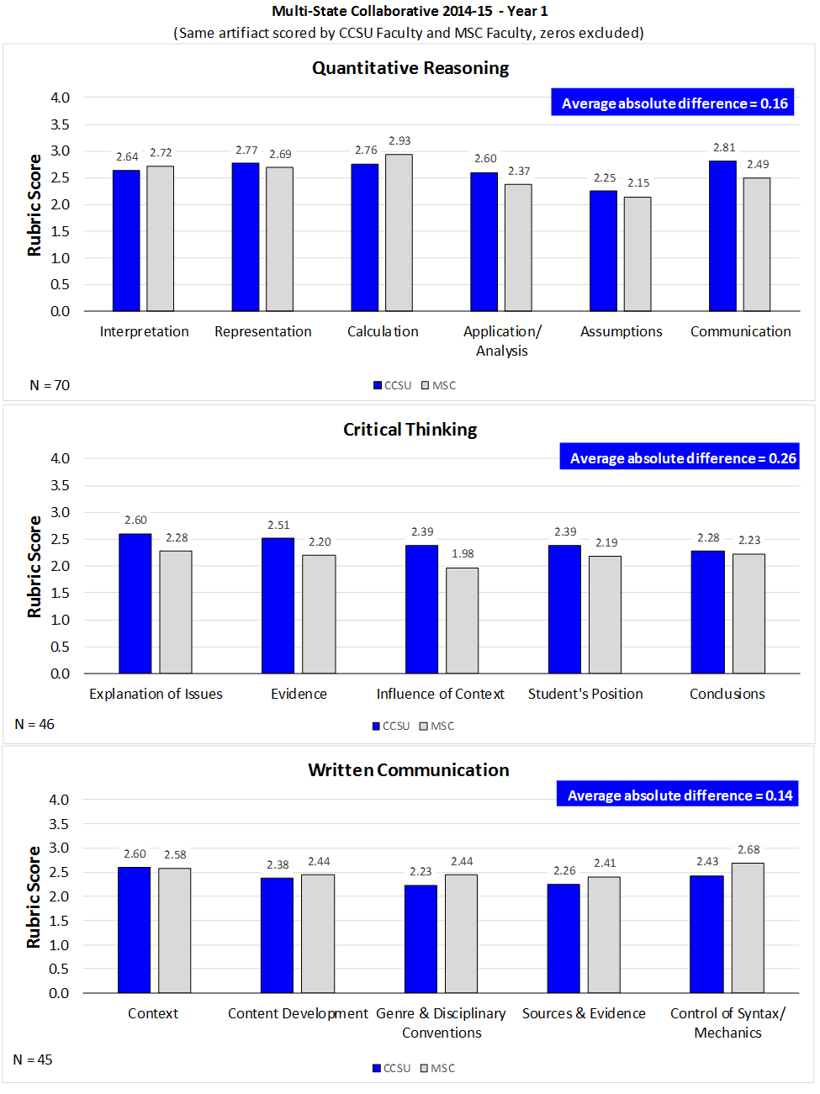

Figure 1. CCSU Faculty Scores compared to MSC Faculty Scores, 2014-15

This high consistency in scoring demonstrated that CCSU faculty were scoring artifacts with a similar critical eye as MSC faculty from other states, thereby validating the results of our first institutional assessment retreat. The pilot year results clearly presented our data within a national context and showed us that the MSC model was, in fact, a sustainable and effective manner by which we could assess our General Education Learning Outcomes.

To date, 58 faculty across 28 academic departments have participated in this campus-based scoring initiative.

**Analysis of Findings from Post-Pilot Years (2015-16 and 2016-17, years 2 and 3, respectively)**

**In** March 2016, the CCSU [Faculty Senate unanimously approved](http://web.ccsu.edu/facultysenate/files/Supporting_Documents_2015-16/FS.15.16.016B.pdf) **to continue piloting the MSC model for two more years; artifacts have continued to be collected and scored for Critical Thinking, Written Communication and Quantitative Reasoning. Additionally, in fall 2016, we began the pilot for assessing** [Civic Engagement](https://www.aacu.org/civic-engagement-value-rubric)**, (CCSU’s Learning Outcome #10: Civic Responsibility) as well as** [Information Literacy](https://www.aacu.org/civic-engagement-value-rubric) **(CCSU’s Learning Outcome #7: Information Fluency and Computer Literacy). In fall 2017, the** [Faculty Senate unanimously adopted](http://web.ccsu.edu/facultysenate/minutes1718nov13.asp) **the MSC-model for General Education assessment at CCSU.**

Our participation in the MSC has given us insight into how our students’ learning compares to national averages for other 4-year institutions. As illustrated in Figure 1, our seniors fare well on Critical Thinking and Quantitative Reasoning, but lag in Written Communication. Although scores can range from 0 to 4, scores of 4 are *aspirational*; that is, only exceptional undergraduates could reach this level of mastery upon graduation. Scores between 2 and 3 reflect proficiency.

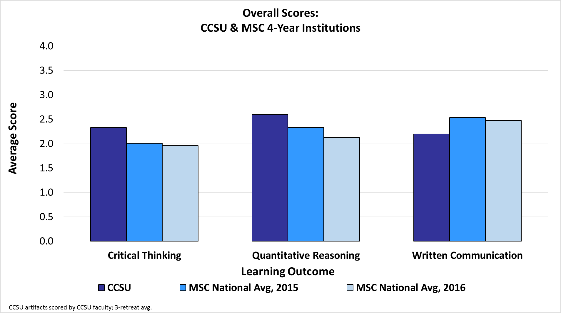

Figure 2. CCSU Seniors Compared to National Results. Artifacts collected in AY2015 & AY2016

**Critical Thinking (CT) Findings (Seniors)**

**Nationally, CCSU Senior artifacts averaged equal to or higher in all Critical Thinking criteria/dimensions than the national 2015 and 2016 MSC averages for seniors. As reported in Table 1 and Figure 2, our students are proficient at** selecting and using *Evidence* to investigate a point of view, presenting a thesis or demonstrating *Student Position,* ***Explanation of Issues,* and *Conclusions and Related Outcomes*. However, 30% of our seniors are only beginning to identify and explore contexts and assumptions (*Influence of Context and Assumptions*). Developing this particular skill is challenging across higher education: Although CCSU seniors scored an average of 2.1, the national average was 1.8.**

Table 6. CCSU Faculty Scoring Critical Thinking Artifacts from CCSU Seniors vs. National Results



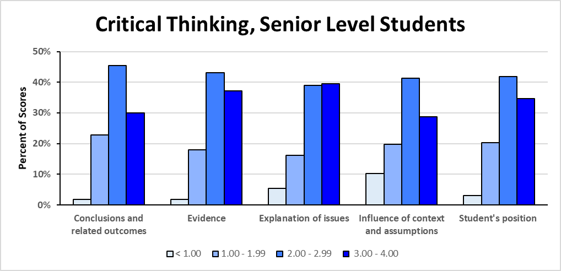 Figure 3. CCSU Faculty Scoring Critical Thinking Artifacts, Retreats 1, 2 & 3

**Quantitative Reasoning (QR) Findings (Seniors)**

**Nationally, CCSU Seniors’ average in Quantitative Reasoning was higher with an overall score of 2.6 compared to the national score of 2.1 and 2.3, respectively. As reported in Table 2 and Figure 3, our students are particularly skilled at *Representing* mathematical forms (e.g., graphs, tables, equations, etc.), interpreting quantitative information *(Interpretation),* and** successfully and comprehensively performing *Calculations*. However, our students exhibit greater difficulty effectively connecting quantitative evidence to an argument (*Communication*) and making/evaluating important *Assumptions* in estimation, modeling, and data analysis. With the exception of the *Communication* dimension, CCSU seniors exceed national averages. We should note that the low score in Assumptions may be related to artifacts not aligning well with the rubric. Even at the national level, scoring assumptions is challenging. Nevertheless, the parallels between expressing assumptions in quantitative reasoning and more generally in critical thinking (see above) warrant further exploration.

Table7. CCSU Faculty Scoring Quantitative Reasoning Artifacts from CCSU Seniors vs. National Results



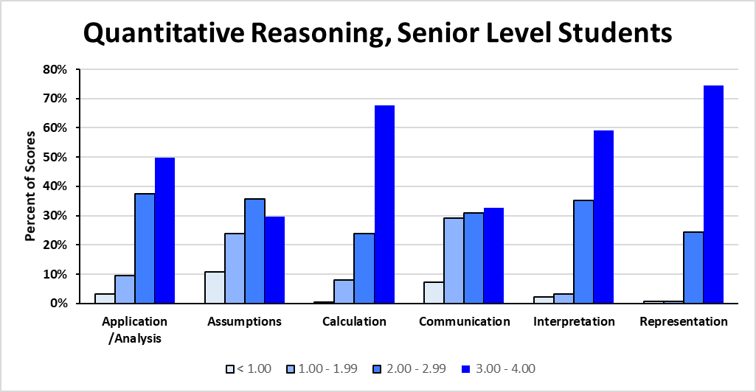

Figure 4. CCSU Faculty Scoring Quantitative Reasoning Artifacts, Retreats 1, 2 & 3

**Written Communication (WC) Findings (Seniors)**

**As reported in Table 3 and Figure 4, our seniors struggle in Written Communication. CCSU Senior artifacts scored lower in all Written Communication criteria/dimensions than the national averages. Still, our students demonstrate the greatest proficiency in Content Development,** *Context of and Purpose for Writing* and in their *Control of Syntax & Mechanics* where they were able to generally convey meaning to readers with clarity, even with some errors in the text. Students’ greatest opportunities for growth include effectively communicating within a genre or discipline (*Genre & Disciplinary Conventions*) and using appropriate sources to support ideas (*Sources and Evidence*).

Table 8. CCSU Faculty Scoring Written Communication Artifacts from CCSU Seniors vs. National Results



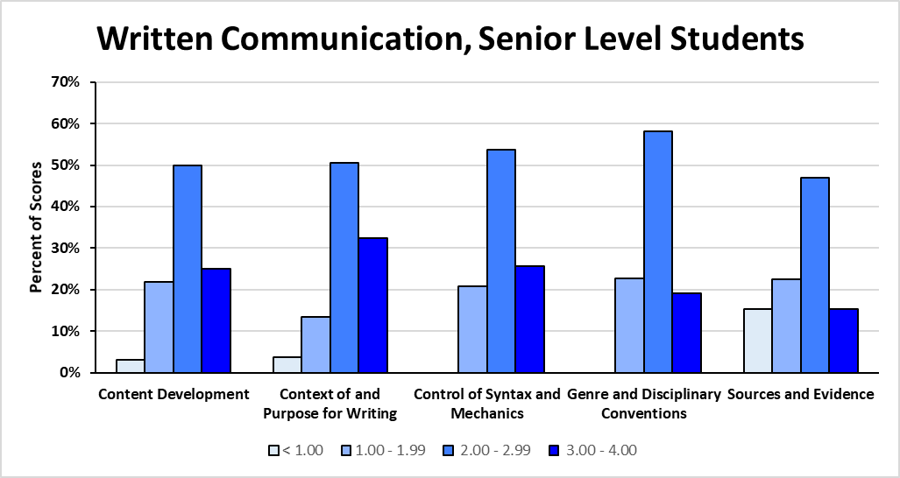

Figure 5. CCSU Faculty Scoring Written Communication Artifacts, Retreats 1, 2 & 3

**Comparison: Freshman to Seniors**

**Although we focus on senior-level artifacts for the basis of national comparisons, we have collected and scored artifacts across class standing. As illustrated in Appendices A through C, seniors demonstrate higher proficiency than first-year students in nearly every dimension.**

**CCSU’s National MSC Recognition** and **Faculty Accomplishments**

CCSU moved beyond its participation in the national MSC to utilize the MSC model at the institution level. The results of these initiatives have been nationally recognized by professional organizations and publications. In an October 16, 2016, the Chronicle of Higher Educationhighlighted CCSU’s GenEd assessment model in a featured article entitled “[*The Next Great Hope for Measuring Learning*](http://www.chronicle.com/article/The-Next-Great-Hope-for/238075)” by Dan Berrett. Additionally, CCSU faculty, staff and administration have been juried into and invited to present at national conferences as well as invited to be panelists at professional Taskstream and AAC&U webinars. Select faculty have also served as consultants to other universities who are in the initial stages of their GenEd assessment journey.

**Key Strengths**

Since 2014, the MSC model has begun to offer a viable faculty-centered method for assessing CCSU’s General Education Learning Outcomes/Objectives and measuring students’ competencies, in keeping with NEASC’s Standard #4: [*The Academic Program*](https://cihe.neasc.org/standards-policies/standards-accreditation/standards-effective-july-1-2016#standard_four)*.* Key strengths and outcomes include:

* Alignment of VALUE rubrics with CCSU’s Learning Outcomes proves to be a viable approach for GenEd assessment on our campus:
* Critical Thinking (LO#4)
* Written Communication (LO#5)
* Quantitative Reasoning (LO#6)
* Information Literacy (LO#7)
* Civic Engagement (LO#10)
* CCSU students scored higher than the national MSC average among other 4-year participating institutions in Critical Thinking, and Quantitative Reasoning but slightly lower in Written Communication.
* **Outcomes of the VALUE rubrics assessment model** helps us determine where students are growing the most, and which competencies may need additional emphasis in the future.
* **85% consistency in scoring outcomes between MSC and CCSU faculty scoring the same artifact externally validates our institutional scoring model as reliable.**
* Strong baseline data for three of our Learning Outcomes - Critical Thinking, Written Communication, and Quantitative Reasoning - with upcoming one year of baseline data in Information Literacy and Civic Engagement.
* **Voluntary faculty participation process in which course-embedded assignments are submitted by faculty representing all schools resulted in minimum additional work for faculty;**
* Personal and confidential dissemination of findings to faculty provides a view of their students’ strengths and areas for growth.

**Areas for Continued Growth**

**Alignment of Assignments with Rubrics**

The alignment of an assignment with the criteria/dimensions of a given rubric is critical for any assessment process and the same is true with this initiative. Faculty who participate are asked to carefully review the rubric and determine if their assignment, as written, links with each rubric criterion/dimension. Some faculty scorers have seen, as a result of participating in scoring, how the revision of their own assignment language can address the alignment issue while further strengthening the communication of learning expectations to their students. AAC faculty will continue to serve as mentors to assist colleagues in developing a shared understanding of the rubric language and in revising, as requested, assignment language to best ensure alignment with rubric criteria/dimensions.

**Continuing to Grow a Positive Assessment Climate on Campus**

At CCSU, faculty participation in the MSC assessment is strictly voluntary. A “grass-roots” model for growing a positive assessment climate on campus has been successful with faculty returning from year to year, new colleagues participating annually, and all taking experiences back and sharing them with their departments. While participating faculty have seen how the VALUE rubrics are professionally relevant for them, OIRA and the Academic Assessment Committee equally recognize the contributions that faculty has made through their feedback and their volunteer service over the last four years. They have been invaluable and will continue to be so as we solicit their future assistance with faculty recruitment, mentoring, and scorer training. We wish to further improve our communication of scoring results with faculty as well as work more closely with them to document changes that they’ve made in their teaching based upon scoring outcomes. We recognize the tasks involved in growing an assessment-friendly campus climate, but the strides that have been achieved thus far are ones upon which we can build.

**Resources and Support for Assessment at CCSU**

**Assessment is one of five major areas for which the Office of Institutional Research and Assessment (OIRA) is responsible. Continued support for GenEd assessment through funding initiatives, support for a campus-based OIRA, and faculty backing is essential as our GenEd Assessment initiative moves forward.** In Fall 2017, the AAC formed an MSC Assessment Sub-Committee, consisting of four faculty members, to work collaboratively with the OIRA director and voluntarily assist in the implementation of the MSC during the 2017-18 academic year. Our goal is to further increase faculty MSC participation on a voluntary basis.

**Establishing a Proposed Timeline: Looking Toward the Future of GenEd Assessment at CCSU**

Since 2014, CCSU has established an effective timeline by which the university’s Learning Outcomes, namely Critical Thinking (CT), Written Communication (WC), Quantitative Reasoning (QR), Information Literacy (IL), and Civic Engagement (CE), have been or will be assessed. The AAC has carefully reviewed timelines for our MSC implementation, and faculty across all schools have voluntarily provided feedback.  Faculty have provided suggestions for the sequence in which our Learning Outcomes should be assessed.  A projected assessment cycle timeline continues the assessment of three General Education dimensions, namely CT, WC, and QR, every other year. The AAC feels that, while all learning outcomes are important, these three learning outcomes are critical, and transcend all programs and disciplines. The assessment of remaining learning outcomes are proposed in the intervening years and, with the [Faculty Senate’s Fall 2017 unanimous approval](http://web.ccsu.edu/facultysenate/minutes1718nov13.asp), we are ready to effectively continue our efforts with GenEd assessment. Table 9 below illustrates a proposed Learning Outcomes assessment timeline and a crosswalk linking NEASC Academic Program standards with VALUE and TAP rubrics and with CCSU GenEd Learning Objectives/Outcomes.)

Table 9. CCSU Crosswalk Linking NEASC Standards, Assessment Rubrics and CCSU GenEd Learning Outcomes.

|  |  |  |  |  |
| --- | --- | --- | --- | --- |
| [NEASC Requirement – Standard 4.15](https://cihe.neasc.org/standards-policies/standards-accreditation/standards-effective-july-1-2016#standard_four) | [VALUE Rubric](http://www.aacu.org/value-rubrics) | [TAP Rubric](http://www.ct.edu/initiatives/tap#gened) | [CCSU GenEd LO](http://ccsu.smartcatalogiq.com/en/current/Undergraduate-Graduate-Catalog/Undergraduate-General-Education-Program) | Proposed Year  Assessed |
| Written Communication | Written Communication |  | 5 | 1, 3, 5 |
| Oral Communication | Oral Communication |  | 5 | 6 |
| Quantitative Reasoning | Quantitative Literacy |  | 6 | 1, 3, 5 |
| Scientific Reasoning | Inquiry & Analysis | Yes | 3 | 4 |
| Scientific Understanding & Knowledge |  | Yes | 3 | 6 |
| Critical Analysis | Critical Thinking |  | 4 | 1, 3, 5 |
| Logical Thinking |  |
| Information Literacy | Information Literacy |  | 7 | 2 |
| Historical Understanding & Knowledge |  | Yes | 2 | 4 |
| Social Phenomena Understanding & Knowledge | Civic Engagement |  | 10 | 2 |
| Aesthetic Appreciation & Knowledge | Creative Thinking | Aesthetic Dimensions | 1 | 2 |
| Ethical Dimensions of Humankind | Ethical Reasoning |  | 9 | 4 |

*Final rubric selections will be made after further consultation with faculty from content areas.

Table 10. Proposed Timeline Sequence for Assessing CCSU GenEd Learning Outcomes

|  |  |  |  |
| --- | --- | --- | --- |
| Year | Learning Outcome Assessed | | |
| 1 | Written Communication | Quantitative Reasoning | Critical Thinking |
| 2 | Civic Engagement | Information Literacy | Aesthetic Appreciation |
| 3 | Written Communication | Quantitative Reasoning | Critical Thinking |
| 4 | Ethical Dimensions | Historical Understanding | Scientific Reasoning |
| 5 | Written Communication | Quantitative Reasoning | Critical Thinking |
| 6 | Oral Communication | Scientific Understanding |  |
| 1 | Written Communication | Quantitative Reasoning | Critical Thinking |
| 2 | Civic Engagement | Information Literacy | Aesthetic Appreciation |
| 3 | Written Communication | Quantitative Reasoning | Critical Thinking |
| 4 | Ethical Dimensions | Historical Understanding | Scientific Reasoning |
| 5 | Written Communication | Quantitative Reasoning | Critical Thinking |
| 6 | Oral Communication | Scientific Understanding |  |

We are drawing upon the “lessons learned” over the past four years to guide us as we move forward while also looking toward new avenues for continued growth in GenEd assessment. The VALUE rubrics provide us with a transdisciplinary GenEd assessment model – one that is not tied to a single course, but rather to key proficiencies that extend beyond single GenEd Study or Skill area course assessments. Although our efforts to measure student learning in Critical Thinking, Written Communication, Quantitative Reasoning, Information Literacy and Civic Engagement have been effective, our work continues as we hope to expand our efforts, carefully considering future outcomes to pilot. We will continue by choosing proficiencies for assessment (a) that are important across majors and disciplines and realistic for our situation at this time of growth, (b) that are directly linked to our Learning Outcomes, (c) that we anticipate will provide us with relevant data for every participating department, and (d) ones that will be well-received by faculty, thus ensuring enthusiasm and continued participation in the assessment process.

**Appendix A**

**Critical Thinking scores for CCSU Faculty Scored Artifacts**

**Freshmen through Seniors, Retreats 1, 2 & 3**

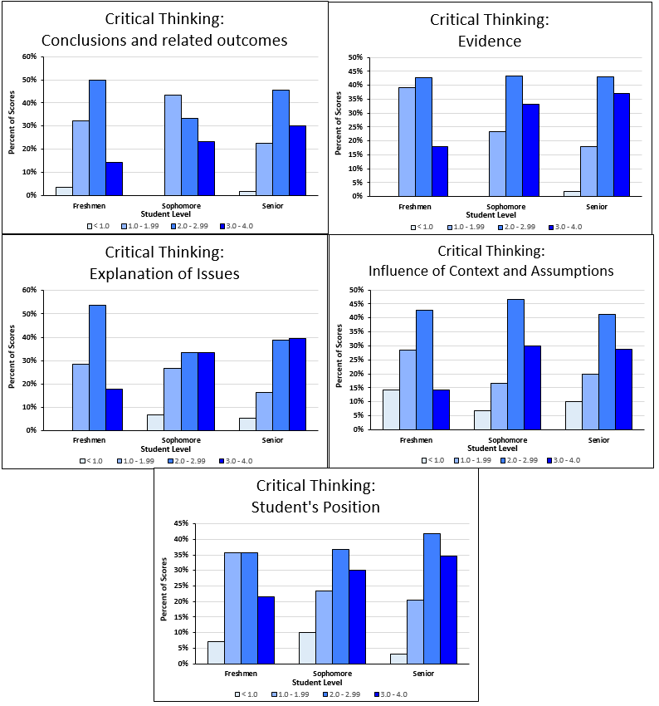

**Appendix B**

**Quantitative Reasoning scores for CCSU Faculty Scored Artifacts**

**Freshmen through Seniors, Retreats 1, 2 & 3**

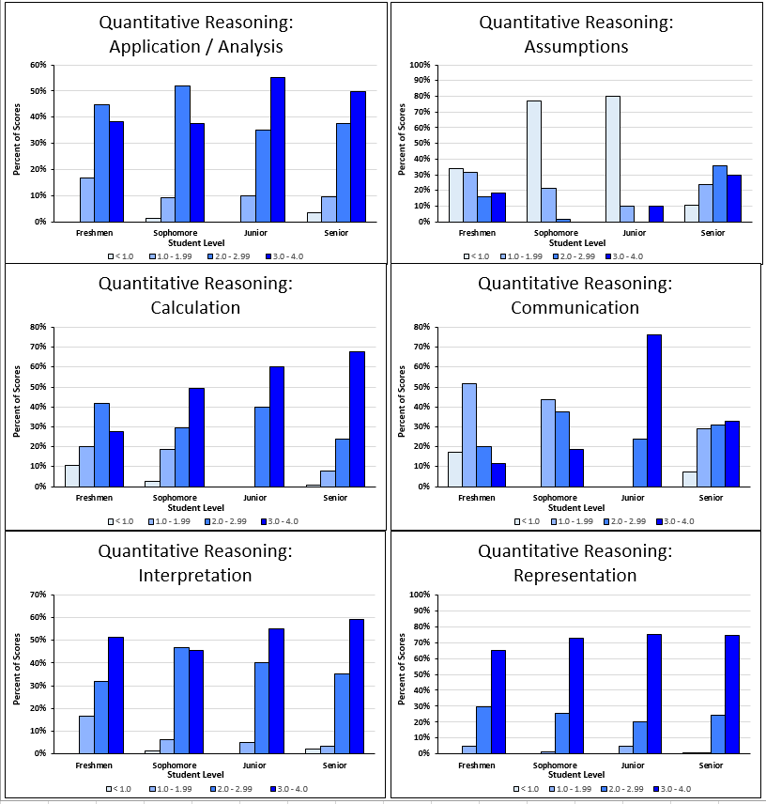

**Appendix C**

**Written Communication scores for CCSU Faculty Scored Artifacts**

**Freshmen through Seniors, Retreats 1, 2 & 3**

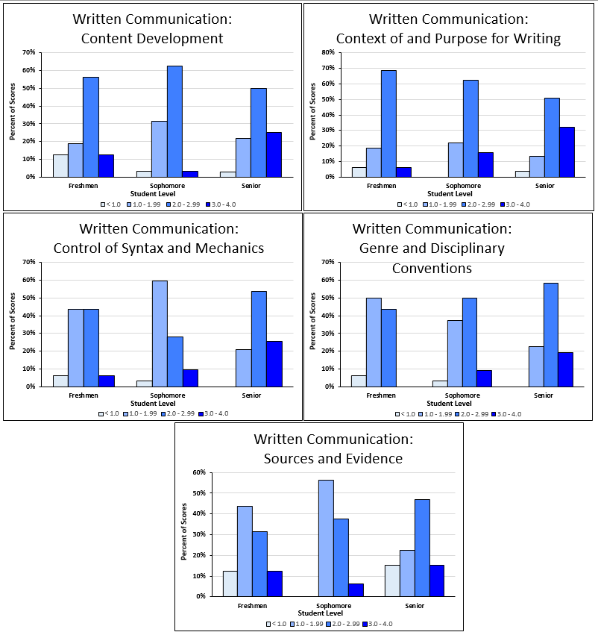

**Appendix D:**

**CCSU Faculty Accomplishments and**

**National Recognition for General Education Assessment**

**Invited and Juried Conference Presentations**

Kirby, Y., Mulrooney, J. & Mullaney, J. (2017, November). *Extending the Multi-State Collaborative Beyond the Initial Goals: Transforming Learning and Assessment*. [New England Educational Assessment Network (NEEAN) 2017 Fall Forum](http://neean.org/resources/Documents/NEEAN%20FF%20Program%20as%20of%209.26.2017.pdf). (Juried Conference Presentation)

In this session, presenters demonstrated how to use the MSC as a model for on-campus assessment of general education learning outcomes in a 2-year and 4-year institution.

Broadus-Garcia, C. (2017, October). *Assessing General Learning Outcomes in the Art Classroom*. 2017 [Connecticut Art Education Association Annual Conference](http://www.ctarteducation.net/uploads/2/6/7/3/26736115/reg_packet_2017_final.pdf), Cromwell, CT. (Juried Conference Presentation)

This presentation showcased how general learning outcomes might be assessed in the art classroom. Using the American Association of College & Universities VALUE rubrics as a model, participants considered how student success can be measured in areas, such as Written and Oral Communication, Ethical Reasoning, Creative and Critical Thinking, Problem Solving, Civic Engagement, and Information Literacy.

Kirby, Y., Mulrooney, J. & Pease, S. (2017, July) *Advancing Outcomes Assessment on Your Campus by Using the Multi-State Collaborative as a Model*.  [American Association of State Colleges and Universities (AASCU) Academic Summer Meeting](http://www.aascu.org/meetings/aa_summer17/preliminaryschedule.pdf), Baltimore MD. (Invited Conference Presentation)

In 2014-15 Central Connecticut State University (CCSU) began participating in the

AAC&U/SHEEO Multi-State Collaborative (MSC), an assessment initiative focused on students who have completed three-quarters of their undergraduate education. The model is simple: identify existing course assignments that align with one of three

VALUE rubrics (written communication, quantitative literacy and/or critical thinking); submit a sample of these assignments for scoring by participating faculty from outside the institution who had been trained to score using the rubrics; and use the resulting scores from the assessment of authentic student work for benchmarking and institutional improvement purposes. In addition to participating in this collaborative project, CCSU has implemented a localized version of the MSC model as a way to advance its general education assessment practices

Horton, Mel (2017, June). *Aqua: A Palette for Advancing Outcomes Assessment*. [Taskstream-TK20 Interactive 2017 conference](http://www.cvent.com/events/taskstream-tk20-interactive-2017/agenda-803a93dcba2e4080985b389dbb638512.aspx), “The Art of Assessment”. Austin, TX. (Invited Presentation)

Session focused on how CCSU successfully generate usable assessment data for their Gen Ed program by institutionally applying the MSC model. Methods for collecting student work from course assignments and aligning these with specific learning outcomes was discussed. CCSU’s use of Aqua to obtain meaningful data was demonstrated and the methods for norming faculty scorers was discussed.

Mulrooney, J., Kirby, Y., Mullaney, J., & McConnell, K. (2017, February). Extending the Multi-State Collaborative: Transforming Learning and Assessment. [AAC&U General Education and Assessment Conference](http://www.aacu.org/meetings/generaleducation/gened2017), “Design Thinking for Student Learning”. Phoenix, AZ (Juried Presentation)

In this session, CCSU and the Community College of Rhode Island demonstrated how to use the MSC foundation as a model for on-campus assessment of general education learning outcomes and how participation in the MSC has helped faculty development focus on improving attainment of learning outcomes. The session illustrated the ease of adjusting existing assignments to better align with a VALUE Rubric. Session participants learned how internal and external data can be used as evidence for accreditation reporting; and how a 2-year and a 4-year campus built upon their participation in the MSC to assess general education undergraduate competencies. Specifically, the session helped participants build a toolkit of strategies around faculty development, assignment (re)design, and campus-based project management of complex, multifaceted, authentic approaches to assessment. Session facilitators provided candid feedback and lessons learned, including a discussion of how to leverage an external project to achieve internal aspirations for assessment and student learning.

Kirby, Y., Lovitt, C., Fitzgerald, G. (2016, December). *High Education Assessment Workshop: Your Mission and Educational Effectiveness*. [NEASC 2016 Conference](https://www.neasc.org/annual-meeting/conference-schedule-2016): Educational Effectiveness through Accreditation. Boston, MA (Invited Presentation).

With the heightened emphasis on quality—how do you demonstrate educational effectiveness that is aligned with your institution’s mission? Through this interactive workshop, using the case-study approach, colleagues from small, middle and large size institutions addressed the challenges and opportunities in creating a culture of assessment and implementing assessment models of student success across the institution.

Kirby, Y. (2016, May). Generating Usable Data for General Education. [Association of Institutional Research (AIR) Forum](https://www1.taskstream.com/presentations/generating-usable-data-for-general-education/), New Orleans, LA.

This presentation highlighted Central Connecticut State University’s ability to quickly generate usable assessment data for their General Education program by applying the model piloted in the Multi-State Collaborative to Advance Learning Outcomes Assessment (MSC). In this session, Kirby presented an overview of the MSC and how it has empowered over 100 two- and four-year institutions to engage faculty in outcomes assessment. In addition, Kirby shared how CCSU was able to collect student work from existing course assignments aligned to specific learning outcomes and obtain usable assessment data within the month using Aqua by Taskstream.

Peagler, C., Aitken, R. & Kirby, Y. (2016, February). *Technology to Advance Faculty-Driven Assessment of Student Work*. [American Association of Colleges & Universities (AAC&U) 2016 General Education Conference](https://www1.taskstream.com/presentations/technology-to-advance-faculty-driven-assessment-of-student-work/), New Orleans, LA.

As the technology partner for AAC&U's VALUE initiative, including the Multi-State Collaborative (MSC) to Advance Learning Outcomes Assessment, Taskstream provides technical guidance and infrastructure to support faculty-driven assessment of student learning based on student work samples from two- and four-year institutions in 16 states that are scored using VALUE rubrics. This session presented feedback from participants in the MSC pilot study and looked at user-friendly technology that enabled AAC&U and the MSC to execute its vision with few technological concerns. Participants learned how Taskstream extended the capabilities of the system to support similar initiatives within and across institutions and how Wright State University and Central Connecticut University use this technology to support general education assessment.

Mulrooney, J., Kirby, Y., Broadus-Garcia, C., Frank, L., & Horton, M. (2015, November). *Assessment on a Dime: Creating a Sustainable and Faculty-Driven Process*. New England Educational Assessment Network (NEEAN) 2015 Fall Forum. (Juried Conference Presentation)

Presenters illustrated CCSU’s approach for assessing academic programs and GenEd that has proven to be effective, evolving and cost neutral. The continuing evolution of the university’s assessment practices were presented, including the results of improved reporting formats and projections for a more sustainable long-term process.

**Online and Print Publications**

American Association of Colleges & Universities. (2017). [On Solid Ground: VALUE Report 2017](http://www.aacu.org/sites/default/files/files/FINALFORPUBLICATIONRELEASEONSOLIDGROUND.pdf), AAC&U, Washington, DC.

This report describes the VALUE rubric approach to assessing student learning showing it is possible to evaluate undergraduate students’ achievement without relying on standardized tests and by using existing material. In On Solid Ground, AAC&U shares the results from the first two years of data collection for the VALUE (Valid Assessment of Learning in Undergraduate Education) initiative, a nationwide project that examines direct evidence of student learning. It represents the first attempt to reveal the landscape of student performance on key learning outcomes—Critical Thinking, Written Communication, and Quantitative Literacy—that educators, employers, and policy makers agree are essential for student success in the workplace and in life. Quotes from CCSU faculty member, Dr. Jim Mulrooney, and OIRA Director, Yvonne Kirby, are highlighted on page 14 of this report.

Berrett, D. (2016, October 21). [The Next Great Hope for Measuring Learning](http://www.chronicle.com/article/The-Next-Great-Hope-for/238075). *The Chronicle of Higher Education*, pp. A30-A33. Retrieved from http://www.chronicle.com/article/The-Next-Great-Hope-for/238075

Thirteen states are using a common tool to evaluate how well their students write, calculate, and think. This article which highlights CCSU’s GenEd assessment model asks, “Can this effort paint an accurate portrait of academic quality?”

Peagler, C. (2016, March 17). [*How to Get Usable Data for General Education*](https://www1.taskstream.com/blog/how-to-get-usable-data-for-general-education/) [Web log post]. Retrieved from https://www1.taskstream.com/blog/how-to-get-usable-data-for-general-education/

Peagler, C. (2016, March 3). [*Good Stuff to Keep from AAC&U Gen Ed 2016*](https://www1.taskstream.com/blog/good-stuff-to-keep-gstk-from-aacu-gen-ed-2016/) [Web log post]. Retrieved from https://www1.taskstream.com/blog/good-stuff-to-keep-gstk-from-aacu-gen-ed-2016/

**Webinar Presentations**

Rhodes, T., Broadus-Garcia, C., Hart, D. A., & Hartlaub, S. (2017, April 17). [*Beyond the "A" Word: Assessment that Empowers Faculty to take Risks with Pedagogical Innovation*](http://www.aacu.org/webinar/assessment-that-empowers) [Invited Audio Webinar]. Retrieved from http://www.aacu.org/webinar/assessment-that-empowers

This webinar, presented by AAC&U, provided practical techniques, strategies, and used cases that demonstrated an approach to assessing student learning that promotes innovation and enables creative practices for marrying teaching and learning with authentic assessment. Panelists provided unique perspectives on how to engage faculty and students in the assessment process in meaningful ways, and outlined their experiences across a wide range of institution types, learning environments, and disciplines. The webinar highlighted On Solid Ground, which outlines the first two years of data collection for AAC&U’s VALUE (Valid Assessment of Learning in Undergraduate Education) initiative, a nationwide project that examines direct evidence of student learning. The VALUE initiative presents a unique approach for colleges and universities that – while methodologically, philosophically, and pedagogically complex – situates defining and measuring the quality of student learning within the learner-faculty relationship, at the course level, without sacrificing questions of rigor. Panelists led a robust discussion of how the VALUE initiative and resources can empower and support faculty to embrace imperfection and take risks by experimenting with pedagogical innovations on their campuses.

Doore, B., Mulrooney, J., & McConnell, K. (2016, June). [*Making Learning Outcomes Data Meaningful at the Local Level: Examples from the MSC/VALUE Initiative*](https://www1.taskstream.com/webinars/making-learning-outcomes-data-meaningful-at-the-local-level-examples-from-the-mscvalue-initiative/)*.* [Invited Audio Webinar]. Retrieved from https://www1.taskstream.com/webinars/making-learning-outcomes-data-meaningful-at-the-local-level-examples-from-the-mscvalue-initiative/

This webinar was the fifth in a MSC/VALUE series presented by AAC&U, SHEEO, and Taskstream and focused on how participating campuses are deriving value from the learning outcomes data generated through this multi-state initiative for their institutions. The webinar (a) showcased strategies for making the data meaningful at the local level; (b) highlighted resources developed by AAC&U and participating campuses; (c) discussed plans for the development of data “toolkits” designed to enhance the utility and meaningfulness of the project for individual campuses.

Switzer, D., Coots, A., Mulrooney, J., & Rhodes, T. (2016, April). [*Faculty Perspectives: Selecting Assignments to Assess Learning Outcomes Using Authentic Student Work*](https://www.aacu.org/node/16663) [Audio Webinar]. Retrieved from https://www.aacu.org/node/16663

This webinar was the fifth in a MSC/VALUE series presented by AAC&U, SHEEO, and Taskstream and focused on the MSC – what worked and what didn’t when it came to identifying assignments and collecting student work samples at their institutions. The presenters shared insights on how courses and assignments were identified, along with examples of assignments that worked well, and how the lessons they learned through their participation in the MSC apply to similar assessment initiatives on individual campuses.

1. Original data regarding national results from the MSC includes zeros in all calculations. Unfortunately, it appears that a value of zero in their dataset has two different definitions: 1) student’s work was not assessed because the assignment did not request that criteria, in which case should be a null value, or 2) assignment did instruct student to address the specific criteria and student failed to do so which should be a zero. CCSU was not provided enough information to recalculate the national scores without zeros.